
BLOOM & BLISS
FLOWER BOUQUET MAKER

A Python Tkinter Desktop Application
Final Project Report
Submitted by
KAVITA KUMARI
(UID: 26MCI10091)
Master of Computer Applications
IN
Artificial Intelligence and Machine Learning (MCA AI & ML)

UNIVERSITY INSTITUTE OF COMPUTING (UIC)
CHANDIGARH UNIVERSITY

Under the Supervision of
[Mr.Ajay Yadav]
OCTOBER 2026
CERTIFICATE
This is to certify that the project report entitled "Bloom & Bliss – Flower Bouquet Maker" has been prepared by Kavita Kumari (UID: 26MCI10091) as part of the academic work for the Master of Computer Applications (AI & ML) programme at the University Institute of Computing, Chandigarh University. The project demonstrates the design and development of a desktop application in Python using the Tkinter graphical user interface library.
Supervisor's Signature: ______________________________________
Name: ______________________________________
Date: ______________________________________

DECLARATION
I declare that this report describes the Bloom & Bliss Flower Bouquet Maker project prepared for academic learning. The application, its screens and the sample data described here are based on the implementation developed in Python with Tkinter. Institutional details and signatures should be completed before submission.
Student Signature: ______________________________________
Student Name: Kavita Kumari

ACKNOWLEDGEMENT
I would like to thank my faculty, my supervisor and the department for the opportunity to learn desktop application development through this project. I also acknowledge the Python community and the official Tkinter documentation, which were the main resources used while building and testing the application. The project helped me understand widgets, layout managers, event handling, image handling, dictionaries, input validation and data storage.
ABSTRACT
Bloom & Bliss is a desktop application that lets a customer design a flower bouquet and place an order through a simple three-step process. It is developed in Python using the Tkinter library. After a welcome screen, the customer selects flowers and quantities from a catalogue of six flowers (Rose, Tulip, Sunflower, Lily, Daisy and Orchid), chooses wrapping and add-ons such as chocolates, and then reviews the bouquet on a Preview and Order screen. The customer enters a full name, a ten-digit phone number, a delivery address, an optional greeting message and a delivery type. A running order summary shows the flower subtotal, the wrapping cost, the add-on cost and the total amount at every step.
The interface uses a consistent plum and pink theme, flower photographs, step tabs and clear navigation buttons. Input validation prevents incomplete or invalid orders, and a View Order History option lets the user look at earlier orders. This is an academic prototype and is not connected to a live florist, payment gateway or delivery service.
TABLE OF CONTENTS
Chapter | Title
1 | Introduction
2 | Problem Statement and Objectives
3 | Scope, Limitations and Feasibility
4 | Requirements and Technologies
5 | System Design
6 | User Interface Design and Screens
7 | Data Structures and Modules
8 | Implementation
9 | Testing and Results
10 | Conclusion and Future Enhancements
11 | Viva Questions and Answers
 | References
LIST OF FIGURES
Figure | Title
Fig. 5.1 | Layered architecture of Bloom & Bliss
Fig. 5.2 | Flowchart of the customer journey
Fig. 5.3 | Use-case diagram
Fig. 5.4 | Data model of the application
Fig. 6.1 | Home screen (welcome page)
Fig. 6.2 | Step 1 – Choose your flowers
Fig. 6.3 | Step 3 – Preview and order
Fig. 7.1 | Flower catalogue – price per stem
Fig. 9.1 | Order total breakdown for the sample order
1. INTRODUCTION
1.1 Background
Flowers are a popular choice for birthdays, anniversaries, festivals and other special moments. Customers usually want to decide which flowers to include, how many stems of each, how the bouquet should be wrapped and what extra gifts, such as chocolates, should be added. When such orders are taken by phone or in person, the details are often written down by hand, and mistakes in quantity, price or address are common.
A small desktop application that guides the customer through each decision and shows the price instantly can remove most of these problems. It also gives the customer a clear picture of the final bouquet before the order is placed.
1.2 About Bloom & Bliss
Bloom & Bliss – Flower Bouquet Maker is a Python Tkinter desktop application that follows a simple three-step wizard. In Step 1 the customer chooses flowers and quantities. In Step 2 the customer selects wrapping and add-ons. In Step 3 the customer previews the bouquet, enters delivery details and places the order. The application is branded with the tagline "Flowers for your special moments" and uses a soft plum and pink colour theme.
1.3 Motivation
The project was chosen to practise building a complete, user-friendly graphical application rather than a command-line program. It combines several important topics of desktop programming: multiple screens, event handling, image handling, data validation, price calculation and record keeping. A flower-ordering workflow is easy to understand, which allows the focus to stay on application design and user experience.
1.4 Organisation of the Report
Chapter 2 states the problem and objectives. Chapter 3 describes scope, limitations and feasibility. Chapter 4 lists requirements and technologies. Chapter 5 presents the system design with diagrams. Chapter 6 explains the user interface with screenshots. Chapter 7 describes data structures and modules. Chapter 8 explains the implementation. Chapter 9 covers testing and results. Chapter 10 gives the conclusion and future work, and Chapter 11 provides viva questions and answers.
2. PROBLEM STATEMENT AND OBJECTIVES
2.1 Problem Statement
Manual bouquet orders depend on verbal descriptions and handwritten notes. The shop and the customer may understand the order differently, prices must be added up by hand, and delivery details can be incomplete. There is no simple way for a customer to see the selected flowers and the running cost before confirming the order.
2.2 Objectives
- Provide an attractive welcome screen with clear options to create a bouquet, view order history, read about the shop and exit.
- Display flowers with photographs and prices per stem, and let the user increase or decrease the quantity of each flower.
- Show a live "Your selection" panel with the number of flowers, the cost of each flower, wrapping, add-ons and the total amount.
- Offer wrapping styles and add-ons such as chocolates that change the total price.
- Collect customer details: full name, phone number, delivery address, greeting message and delivery type.
- Validate the entered details so that incomplete or invalid orders cannot be placed.
- Save placed orders so that they can be viewed later in the order history.
- Keep the interface simple, consistent and easy to navigate with back and next buttons.
2.3 Proposed Solution
The proposed solution is a Tkinter application with a step-based interface. A tab bar at the top shows the three steps and highlights the current one. The order summary panel stays visible on the right so that the customer always knows the current cost. Navigation buttons at the bottom move the user forward and backward without losing the selections.
3. SCOPE, LIMITATIONS AND FEASIBILITY
3.1 Scope
- The application contains six flower types with images and prices.
- It supports wrapping selection and add-ons, with chocolates as a sample add-on.
- It collects customer information and places an order with a calculated total.
- It includes Home, Order History and About screens in addition to the three ordering steps.
- The catalogue, prices and options can be extended by editing the data in the program.
3.2 Limitations
- The project is not connected to a real florist, payment gateway or delivery partner.
- There is no user login, stock management or administrator panel.
- Prices, flower names and customer data used in the report are sample data.
- The application runs only on a desktop computer with Python; it is not a web or mobile application.
- Orders are stored locally and are not synchronised with any online database.
3.3 Feasibility Study
Type | Assessment
Technical | Python and Tkinter are free, available on all major operating systems and sufficient for the required screens, images and logic.
Economic | No paid software or hardware is needed. The project can be developed and run on an ordinary personal computer.
Operational | The three-step design and clear labels make the application easy to use for customers with no technical knowledge.
Schedule | The project is small enough to be designed, coded and tested within one academic semester.
4. REQUIREMENTS AND TECHNOLOGIES
4.1 Hardware Requirements
Component | Minimum Requirement
Processor | Dual-core processor, 1.5 GHz or higher
Memory (RAM) | 2 GB or more
Storage | 100 MB free disk space for the program, images and order records
Display | 1366 × 768 resolution or higher (the application is designed for a large window)
Input devices | Keyboard and mouse
4.2 Software Requirements
Component | Requirement
Operating system | Windows 10 or 11 (also works on Linux and macOS with Python)
Language | Python 3.x
GUI library | Tkinter and ttk (included with standard Python)
Image support | Pillow (PIL) library for loading and resizing flower photographs
Editor | IDLE, VS Code or any Python editor

4.3 Tools and Technologies Used
Technology | Use
Python 3 | Main programming language used for all application logic.
Tkinter | Standard Python library used to build windows, frames, labels, buttons and entries.
ttk widgets | Provide the Combobox used for the delivery type and themed buttons.
Pillow | Opens, resizes and displays the flower photographs.
Messagebox | Shows warnings, confirmations and error messages.
File handling | Stores placed orders so that they appear in the order history.

4.4 Why Tkinter?
Tkinter was chosen because it is part of the standard Python installation, needs no extra setup and is well documented. It provides all the widgets required for this project, and its grid and pack layout managers make it possible to create a clean and responsive layout. Because it is lightweight, the application starts quickly and runs smoothly even on low-end computers.
5. SYSTEM DESIGN
The design of Bloom & Bliss is described below using four diagrams: the layered architecture, the flowchart of the customer journey, the use-case diagram and the data model.
5.1 System Architecture
The application is organised into three layers. The presentation layer contains all Tkinter screens. The application logic layer manages the bouquet, calculates prices, validates input and builds the order. The data layer holds the flower catalogue, the flower images and the saved order records. Keeping these layers separate makes the program easier to understand, test and extend.
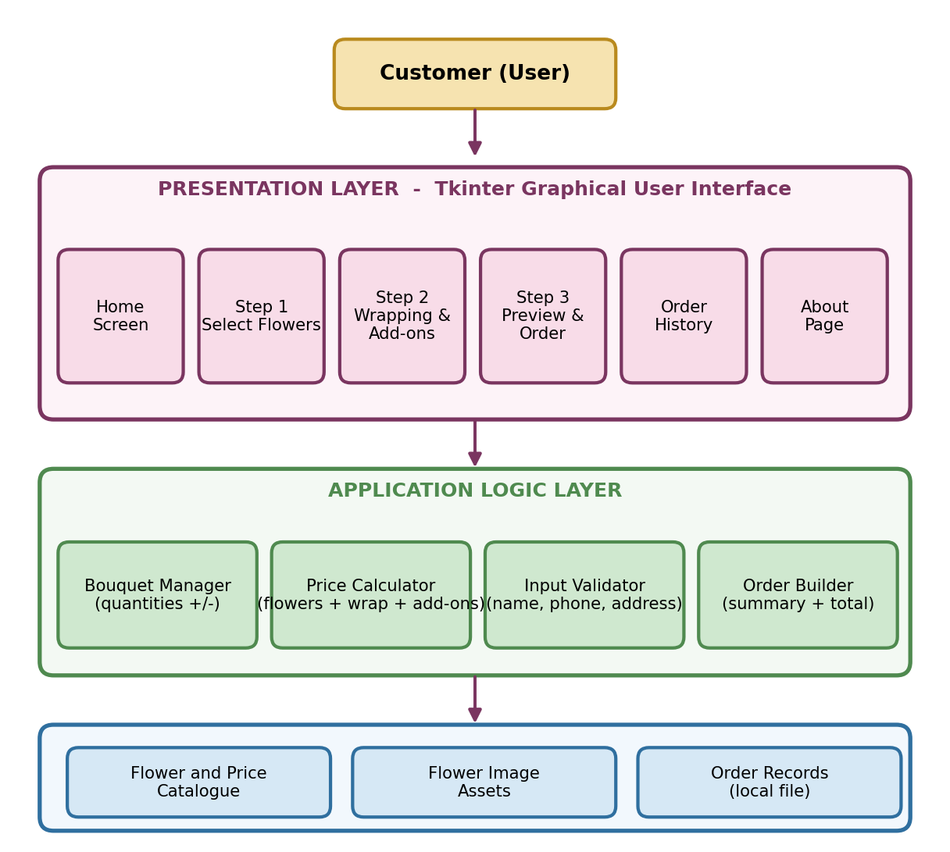
Fig. 5.1 Layered architecture of Bloom & Bliss
5.2 Flowchart of the Customer Journey
The customer starts at the Home screen and clicks Create New Bouquet. After choosing flowers, the customer moves through the wrapping and preview screens. If no flower has been selected, or if the details are invalid, the application shows a message and returns the user to the relevant step. When everything is valid, the order is placed, saved and confirmed.
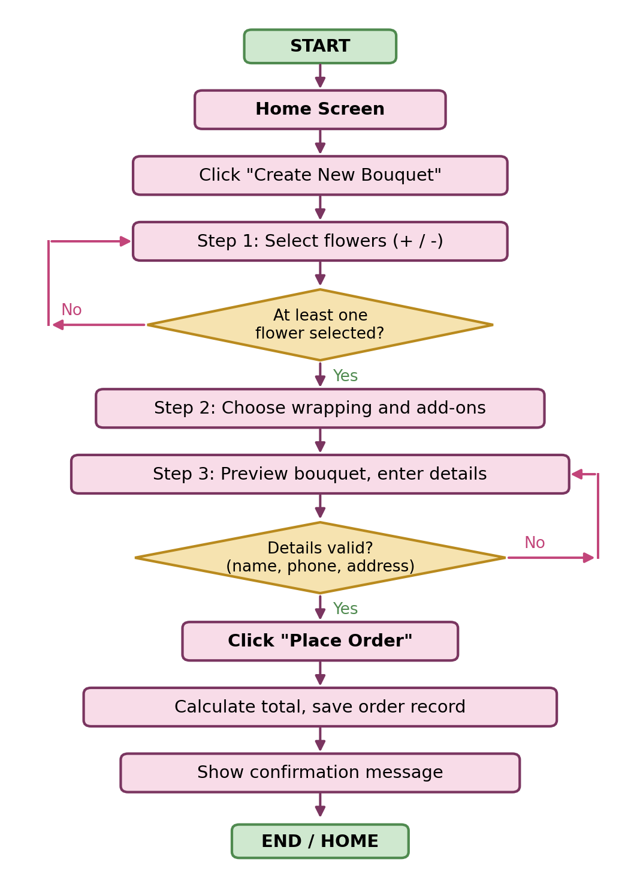
Fig. 5.2 Flowchart of the customer journey
5.3 Use-Case Diagram
The customer is the only actor in the system. The diagram shows the actions available to the customer: selecting flowers, adjusting quantity, choosing wrapping and add-ons, previewing the bouquet, entering details, placing the order, and viewing the order history and About page.
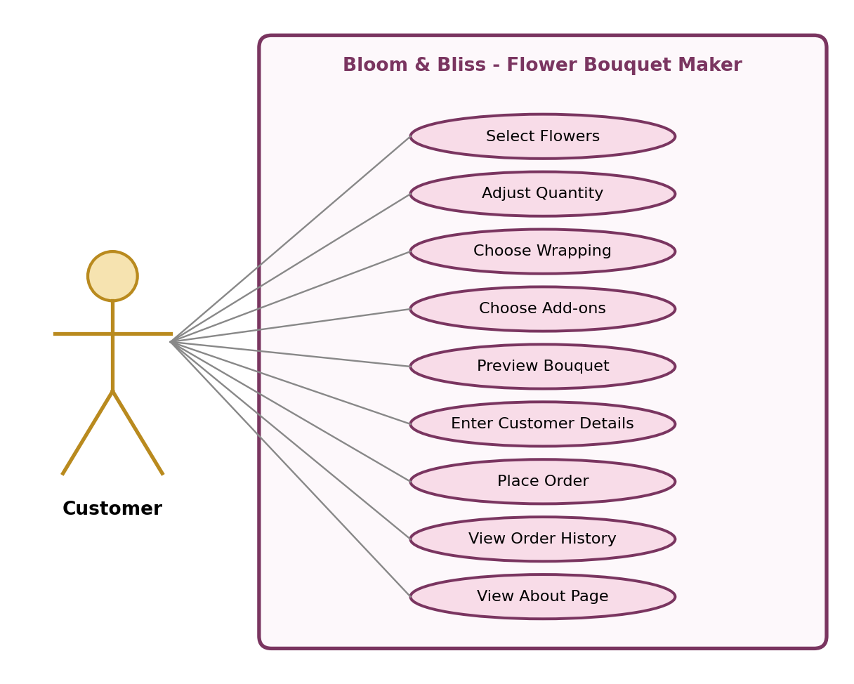
Fig. 5.3 Use-case diagram
5.4 Data Model
The program stores its data in simple structures. The FLOWERS, WRAPPING and ADD-ONS catalogues hold names and prices. The BOUQUET (cart) holds the quantity chosen for each flower. The CUSTOMER structure holds the details typed by the user, and the ORDER combines the bouquet, the customer and the calculated costs into a single record.
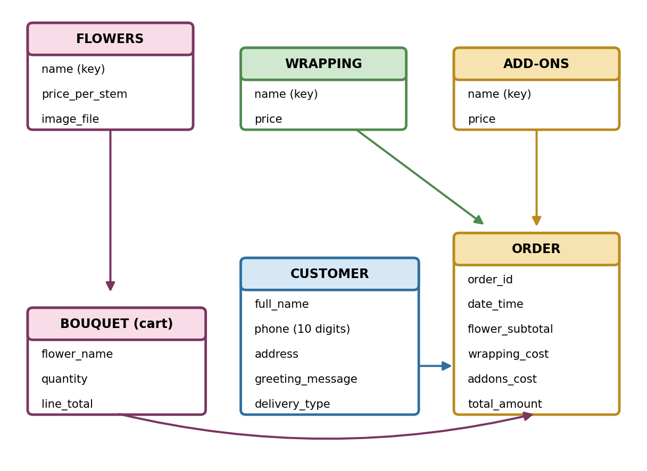
Fig. 5.4 Data model of the application
6. USER INTERFACE DESIGN AND SCREENS
6.1 Design Theme
The interface uses a warm plum and soft pink theme that suits the subject of flowers. Headings use a bold serif typeface to give an elegant look, while labels and buttons use a clean sans-serif typeface for readability. Primary action buttons are filled with plum, and secondary buttons are white. A decorative script font is used for the title on the home screen.
Element | Style
Primary colour | Plum (used for headings, active step tab and main buttons)
Background | Very light pink for pages and panels, white for cards
Accent | Pink band with flower symbols on the home screen header
Headings | Bold serif font in plum colour
Body text | Sans-serif font in dark grey
Branding | Flower logo, "Bloom & Bliss" name and the tagline "Flowers for your special moments"
Footer | "Made with love ♥ Bloom & Bliss Flower Studio" on every screen
6.2 Home Screen
The home screen welcomes the user with the heading "Welcome to Bloom & Bliss". The pink header shows the title "Flower Bouquet Maker" with the words Fresh Flowers, Beautiful Bouquets and Special Moments and small flower symbols at the corners. The left card shows a photograph of a red rose bouquet with the lines "A bouquet made with love" and "For You". The right side briefly explains the three actions: choose favourite fresh flowers, add a beautiful wrap and little extras, and preview the bouquet and place the order.
Four buttons are provided: Create New Bouquet (the main plum button), View Order History, About Bloom & Bliss and Exit.
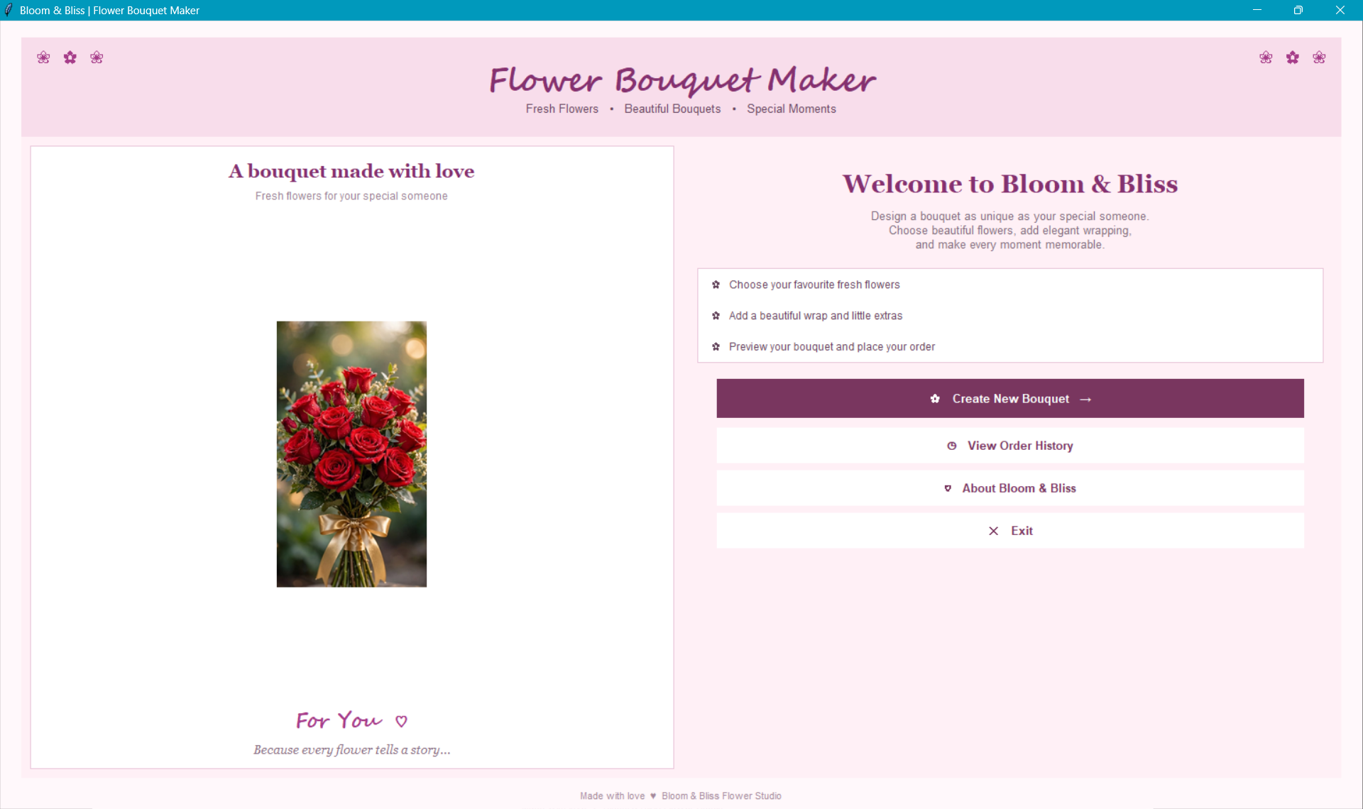
Fig. 6.1 Home screen (welcome page)
6.3 Step 1 – Select Flowers
The first step is titled "Choose your flowers". The flowers are shown as cards in a grid of three columns and two rows: Rose, Tulip, Sunflower, Lily, Daisy and Orchid. Each card contains a photograph, the flower name and the price per stem. Below the price are a minus button, the current quantity and a plus button, which let the customer change the number of stems.
At the right, a "Your selection" panel lists the number of flowers selected, the selected flowers with their cost, the wrapping cost, the add-on cost and the total amount in a large serif font. In the screenshot, three Tulips (Rs. 180) and one Sunflower (Rs. 70) are selected, with default wrapping of Rs. 50, giving a total of Rs. 300. The Home button returns to the welcome screen, and the Next: Wrapping & Add-ons button moves to Step 2.
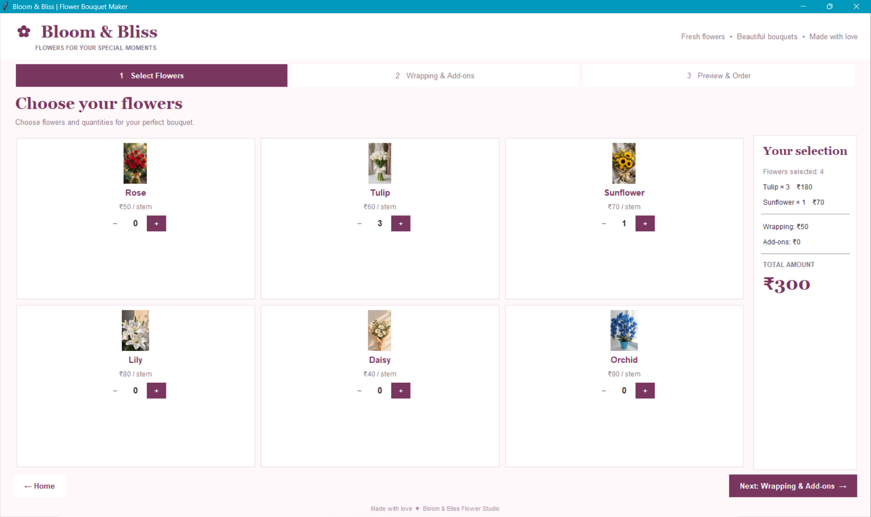
Fig. 6.2 Step 1 – Choose your flowers
6.4 Step 2 – Wrapping and Add-ons
The second tab, "Wrapping & Add-ons", lets the customer decorate the bouquet. The customer chooses a wrapping style, for example the Jute Wrap, and may add extras such as chocolates. Each choice has its own price, and the order summary on the right is updated immediately. A back button returns to Step 1 without losing the selected flowers, and a next button moves to the preview screen.
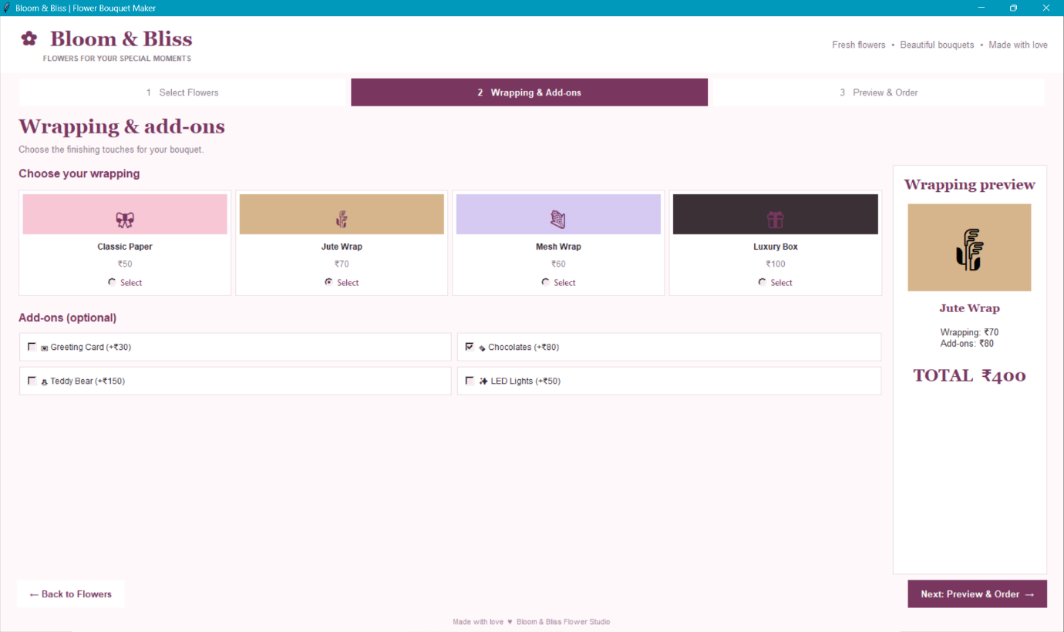
6.5 Step 3 – Preview and Order
The third step, "Preview & order", asks the customer to check the bouquet and enter customer details. The "Your bouquet" card lists every flower with its quantity and cost. Below it, the "Customer information" form contains the fields Full name, Phone number (10 digits), Delivery address, Greeting message and Delivery type (a drop-down list with Home Delivery as the selected option).
The "Order summary" panel on the right shows the flower subtotal (Rs. 250), the wrapping cost (Jute Wrap, Rs. 70), the chocolates add-on (Rs. 80) and the total amount of Rs. 400. The Back to Wrapping button returns to Step 2, and the Place Order button confirms the order.
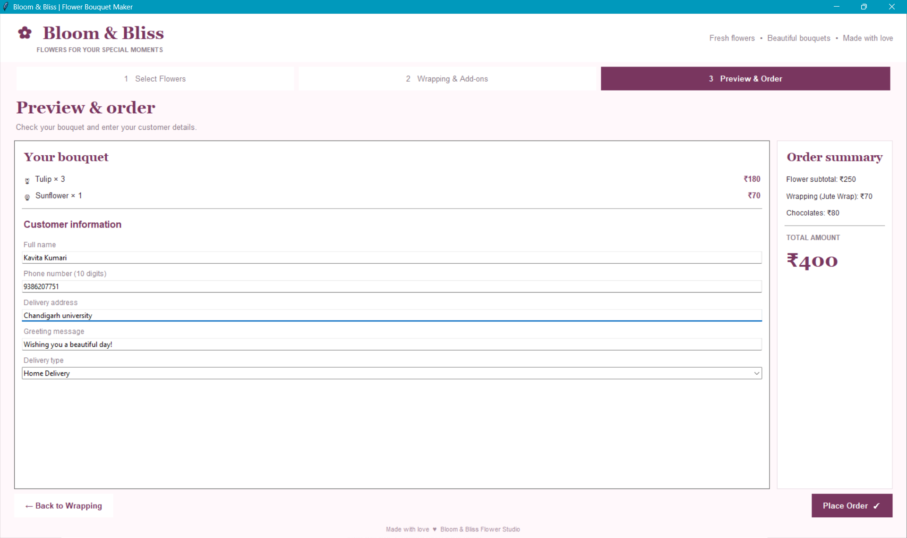
Fig. 6.3 Step 3 – Preview and order
6.6 Usability Features
- A step tab bar always shows where the customer is and what comes next.
- The order summary is always visible, so there are no surprises in the final price.
- Flower photographs help the customer recognise each flower quickly.
- Large buttons and clear labels make the application easy to use with a mouse.
- The label "Phone number (10 digits)" tells the user the required format before an error occurs.
- The footer and header keep the same branding on every screen.
7. DATA STRUCTURES AND MODULES
The program keeps its data in Python dictionaries and variables. The tables in this chapter describe the catalogue, the customer fields and the main functions.
7.1 Flower Catalogue
Flower | Price per Stem | Description
Daisy | Rs. 40 | Small, cheerful white flowers; lowest-priced option
Rose | Rs. 50 | Classic red rose, the symbol of love
Tulip | Rs. 60 | Elegant white tulips with a soft look
Sunflower | Rs. 70 | Bright yellow flowers that give a cheerful bouquet
Lily | Rs. 80 | Large white lilies with a gentle fragrance
Orchid | Rs. 90 | Premium blue orchid; highest-priced option

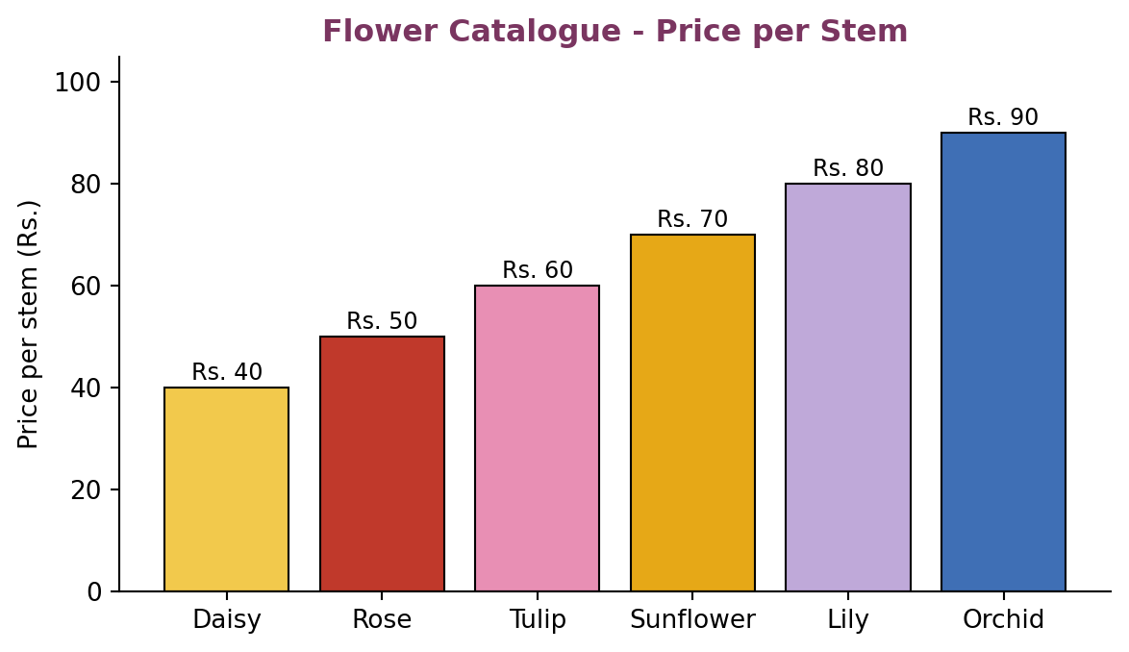
Fig. 7.1 Flower catalogue – price per stem

7.2 Wrapping and Add-ons
Option | Category | Price
Standard wrapping (default) | Wrapping | Rs. 50
Jute Wrap | Wrapping | Rs. 70
Chocolates | Add-on | Rs. 80
No add-on | Add-on | Rs. 0

7.3 Customer Information Fields
Field | Widget | Rule
Full name | Entry | Required; must not be empty
Phone number | Entry | Required; exactly 10 digits
Delivery address | Entry | Required; must not be empty
Greeting message | Entry | Optional text printed on the greeting card
Delivery type | Combobox | Selected from a list; Home Delivery is the default

7.4 Main Functions
Function | Purpose
show_home() | Displays the welcome screen with the four main buttons.
show_step(n) | Displays Step 1, 2 or 3 and highlights the matching tab.
change_qty(flower, delta) | Increases or decreases the quantity of a flower (never below zero).
calculate_total() | Returns flower subtotal plus wrapping and add-on costs.
update_summary() | Refreshes the "Your selection" and "Order summary" panels.
validate_customer() | Checks name, phone number and address before placing the order.
place_order() | Builds the order record, saves it and shows a confirmation.
show_history() | Displays previously placed orders.
8. IMPLEMENTATION
This chapter explains the main parts of the program. The code excerpts below show the logic in a simplified form; variable and widget names should be matched with the final source file before submission.
8.1 Catalogue Data
The prices are stored in dictionaries so that they can be changed in one place. The cart is another dictionary that maps each flower name to the number of stems selected.
FLOWERS = {"Daisy": 40, "Rose": 50, "Tulip": 60,
"Sunflower": 70, "Lily": 80, "Orchid": 90}
WRAPPING = {"Standard": 50, "Jute Wrap": 70}
ADDONS = {"None": 0, "Chocolates": 80}

cart = {name: 0 for name in FLOWERS}
8.2 Creating the Main Window
The main window is created with Tk(), given a title and set to open maximised. A header frame, a tab bar, a content frame and a footer are created once, and the content frame is cleared and refilled each time the user moves to another screen.
root = tk.Tk()
root.title("Bloom & Bliss | Flower Bouquet Maker")
root.state("zoomed")
root.configure(bg="#FDF3F8")

content = tk.Frame(root, bg="#FDF3F8")
content.pack(fill="both", expand=True)
8.3 Changing Quantities
Each flower card has a minus and a plus button. The change_qty function updates the cart, makes sure the quantity never becomes negative, and refreshes the quantity label and the order summary.
def change_qty(name, delta):
cart[name] = max(0, cart[name] + delta)
qty_labels[name].config(text=str(cart[name]))
update_summary()
8.4 Calculating the Total
The total amount is the sum of the price multiplied by the quantity for every flower, plus the cost of the selected wrapping and add-on.
def flower_subtotal():
return sum(FLOWERS[n] * q for n, q in cart.items())

def calculate_total():
return (flower_subtotal()
+ WRAPPING[wrap_var.get()]
+ ADDONS[addon_var.get()])
8.5 Moving Between Steps
Before moving from Step 1 to Step 2, the program checks that at least one flower has been selected. If not, a message box asks the customer to choose a flower first.
def go_to_wrapping():
if flower_subtotal() == 0:
messagebox.showwarning("No flowers",
"Please select at least one flower.")
return
show_step(2)
8.6 Validating Customer Details
The validation function checks that the name and address are not empty and that the phone number contains exactly ten digits. The first problem found is reported to the user and the order is not placed.
def validate_customer():
if not name_var.get().strip():
return "Please enter your full name."
phone = phone_var.get().strip()
if not (phone.isdigit() and len(phone) == 10):
return "Phone number must be exactly 10 digits."
if not address_var.get().strip():
return "Please enter the delivery address."
return None
8.7 Placing and Saving the Order
When the user clicks Place Order, the program validates the details. If everything is correct, it creates an order record with the customer information, the selected flowers, the costs and the total, saves it to a file and shows a confirmation message.
def place_order():
error = validate_customer()
if error:
messagebox.showerror("Invalid details", error)
return
order = {
"customer": name_var.get().strip(),
"phone": phone_var.get().strip(),
"address": address_var.get().strip(),
"message": message_var.get().strip(),
"delivery": delivery_var.get(),
"items": {n: q for n, q in cart.items() if q > 0},
"total": calculate_total(),
}
save_order(order)
messagebox.showinfo("Order placed", "Thank you! Your order is placed.")
show_home()
8.8 Error Handling and User Messages
- A warning appears if the customer tries to continue without selecting any flower.
- An error message is shown for an empty name, an invalid phone number or an empty address.
- Quantities cannot go below zero because the minus button stops at zero.
- The total is recalculated after every change, so the displayed price is always correct.
9. TESTING AND RESULTS
9.1 Test Cases
The following test cases verify the main features. Actual output depends on the selections made during the test.
Test | Action | Expected Result
TC-01 | Start the application | Home screen opens with the welcome text and four buttons.
TC-02 | Click Create New Bouquet | Step 1 "Choose your flowers" opens with six flower cards.
TC-03 | Click + on Tulip three times | Quantity shows 3 and the selection panel shows Tulip × 3, Rs. 180.
TC-04 | Click + on Sunflower once | Sunflower × 1, Rs. 70 is added; flower subtotal becomes Rs. 250.
TC-05 | Click – on a flower with quantity 0 | Quantity stays at 0; it never becomes negative.
TC-06 | Click Next with no flower selected | A message asks the user to select at least one flower.
TC-07 | Click Next: Wrapping & Add-ons | Step 2 opens and the second tab is highlighted.
TC-08 | Select Jute Wrap | Wrapping cost changes to Rs. 70 and the total updates.
TC-09 | Select Chocolates add-on | Add-on cost becomes Rs. 80 and the total updates.
TC-10 | Go to Step 3 | Bouquet items, customer form and order summary are displayed.
TC-11 | Leave Full name empty and click Place Order | Error message asks for the full name.
TC-12 | Enter a 9-digit phone number | Error message says the phone number must be 10 digits.
TC-13 | Enter letters in the phone number | Error message says the phone number must be 10 digits.
TC-14 | Leave Delivery address empty | Error message asks for the delivery address.
TC-15 | Leave Greeting message empty | Order is still accepted because the message is optional.
TC-16 | Choose Home Delivery from the list | Delivery type is stored with the order.
TC-17 | Click Back to Wrapping | Step 2 opens and earlier selections are kept.
TC-18 | Enter valid details and click Place Order | Order is saved and a confirmation message is shown.
TC-19 | Click View Order History | The placed order appears in the history.
TC-20 | Click Exit | The application closes.
9.2 Worked Example
The Preview and Order screen in Fig. 6.3 shows a sample order. The customer selected 3 Tulips at Rs. 60 each (Rs. 180) and 1 Sunflower at Rs. 70, so the flower subtotal is Rs. 250. The Jute Wrap costs Rs. 70 and the chocolates add-on costs Rs. 80. The total amount is therefore 250 + 70 + 80 = Rs. 400, which matches the amount shown in the order summary.
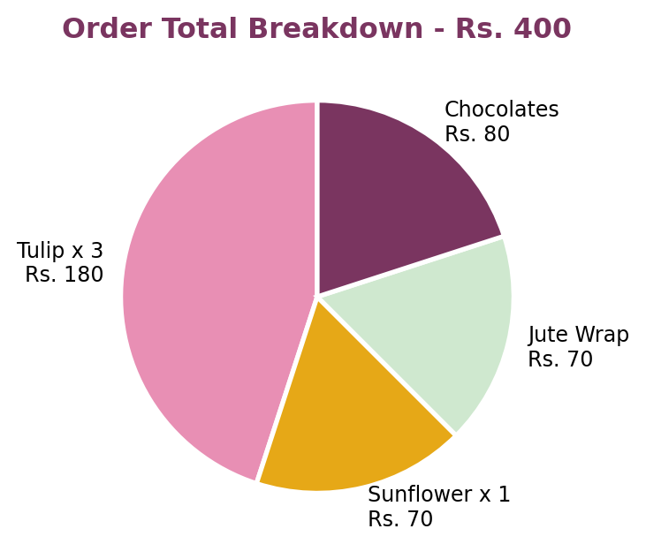
Fig. 9.1 Order total breakdown for the sample order
9.3 Results and Discussion
All major features worked as expected during testing. The step tabs, quantity buttons and order summary responded immediately to each action. The totals matched hand calculations in every test, and invalid input was rejected with clear messages. The interface remained consistent across the screens, and the flower photographs made it easy to identify each option.
Feature | Result
Navigation between screens | Works correctly in both forward and backward directions
Quantity control | Quantity never goes below zero; summary updates instantly
Price calculation | Matches manual calculation for all tested combinations
Input validation | Invalid name, phone and address are detected before ordering
Order saving | Valid orders are saved and can be seen in the order history
User interface | Consistent colour theme, readable text and clear buttons
10. CONCLUSION AND FUTURE ENHANCEMENTS
10.1 Conclusion
Bloom & Bliss demonstrates how a complete and attractive desktop application can be built with Python and Tkinter. The program guides the customer through selecting flowers, choosing wrapping and add-ons, and placing an order, while an always-visible summary shows the cost. Validation protects the quality of the order data, and the plum-and-pink design with flower photographs gives the application a professional appearance.
The project strengthened my understanding of GUI design, multi-screen navigation, event handling, image handling, data validation and file handling. It also showed the importance of simple, consistent design for the end user.
10.2 Advantages
- Simple three-step workflow that anyone can follow.
- Instant price calculation with no manual errors.
- Attractive interface with photographs and a consistent theme.
- Runs on an ordinary computer with only free software.
- Easy to extend with new flowers, wrapping styles and add-ons.
10.3 Future Enhancements
- Store flowers, customers and orders in a database such as SQLite or MySQL.
- Add online payment and order tracking.
- Add user login and an administrator panel to manage stock and prices.
- Generate a printable PDF invoice and send it by email or SMS.
- Show a live visual preview of the arranged bouquet.
- Use machine-learning techniques to recommend bouquets for occasions such as birthdays and anniversaries.
- Develop a web or mobile version of the application.
REFERENCES
1. Python Software Foundation, Python 3 Documentation – tkinter: Python interface to Tcl/Tk.
2. TkDocs, Tkinter Tutorial and Widget Reference.
3. Python Software Foundation, The Python Tutorial – Data Structures and Input/Output.
4. Pillow (PIL Fork) Documentation – Image Module.
Github: https://github.com/Kavitakumri23/Flower_Bouquet_Maker14.git

